Day 1 Revisit

Spring Framework

* What is Spring? – Is a Popular Java Framework developed to resolve challenges in creating Enterprise Applications
* Why Spring? – Used for creating Loosely coupled Enterprise Java Application quickly and easily.
* Important Design Pattern. – IoC (Inversion Of Control), DI (Dependency Injection)
* Bean – Object created by IoC Container in Spring Framework
* Configuring Beans – Using XML file & using Annotations
* Modules of Spring Framework – Core, AOP, WebMVC, Data, Security etc.,
* Examples – Adding jars to build path.
* Bean Scopes – Singleton, prototype, Application, session, request, websocket
* Application Context
* BeanFactory

JPA

* What is JPA?
* JPA Implementations.
* How to use JPA
* What is JPQL
* What is Hibernate?
* How to create Hibernate based Apps
* Hibernate configuration & Hibernate Mapping
* HQL
* Features of Hibernate

JPA – Java Persistence API

API – Application Programming Interfaces

In Java, What API is used to interact with databases?

JDBC – Java Data Base Connectivity.

JPA simplifies the task of interacting with any database.

JDBC – CRUD Operation

C- Create/Insert (Insert Query) -int (Number of rows affected)

R – Read (Select query) – ResultSet

U – Update (Update Query) -int (Number of rows affected)

D – Delete (Delete query) -int (Number of rows affected)

JDBC API

<https://docs.oracle.com/javase/8/docs/api/>

JDBC is a Specification – It contains many Interfaces.

5 Steps in interacting to a Database using JDBC

1. Loading & Registering the Driver
2. Establishing the connection
3. Creating & Executing the Query
4. Store & Process the Result
5. Close all Resources

Printer --- Connect with your laptop

1. Download and Install Drivers
2. Establishing the connection with laptop (Using cables/wifi)
3. Test Print
4. Print actual Document
5. Power off printer (Closing Resources)

Oracle – Oracle Driver (ojdbc.jar)

MySQL – MySQL Driver (connectorj.jar)

Postgres -Postgres Driver

DB2

MSSQL

MySQL Driver Jar Location – “C:\Program Files (x86)\MySQL\Connector J 8.0\mysql-connector-java-8.0.23.jar”

MySQL Driver Download URL -- <https://dev.mysql.com/downloads/connector/j/8.0.html>

JDBC – MySQL/MSSQL/Oracle/DB2/Postgres

3 ways of Interacting with Database

1. Using CLI (Command Line Client) – CUI – Character User Interface – Knowledge of SQL queries is essential.
2. Using GUI (Graphical User Interface) Applications – MySQL Workbench (DB GUI Client for MySQL)
3. Using any Programming Lang (JAVA, Python, JSP, ASP, .Net)

Open MySQL Command Line client (mysql)

Enter the “root” user password

Mysql> show databases;

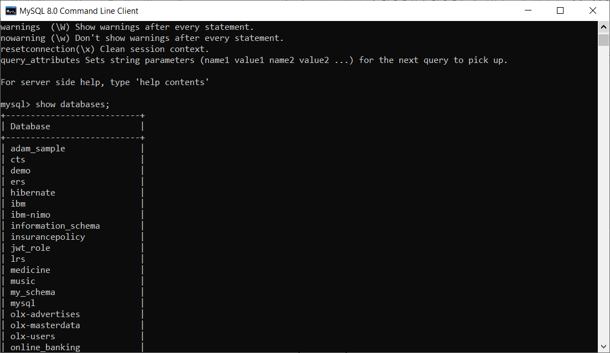

Create schema tcs1;

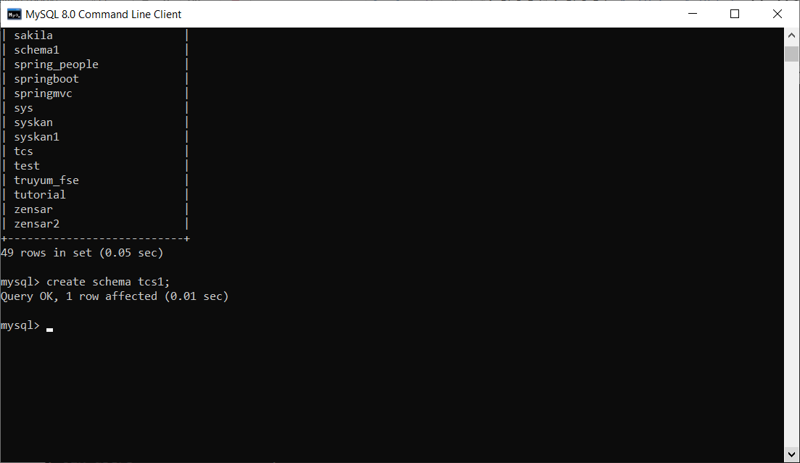

Use tcs;

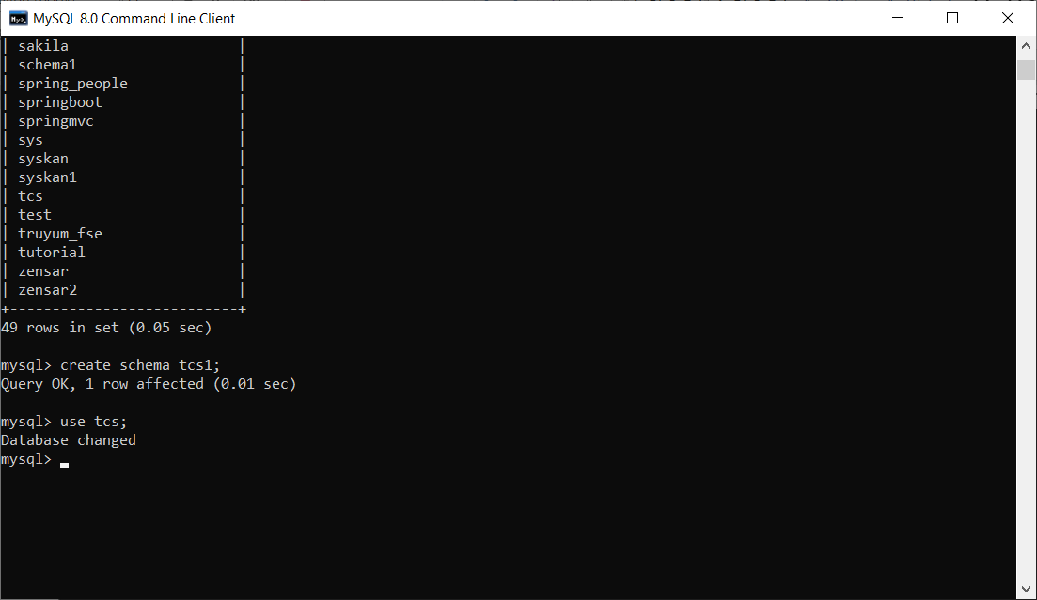

Show tables;

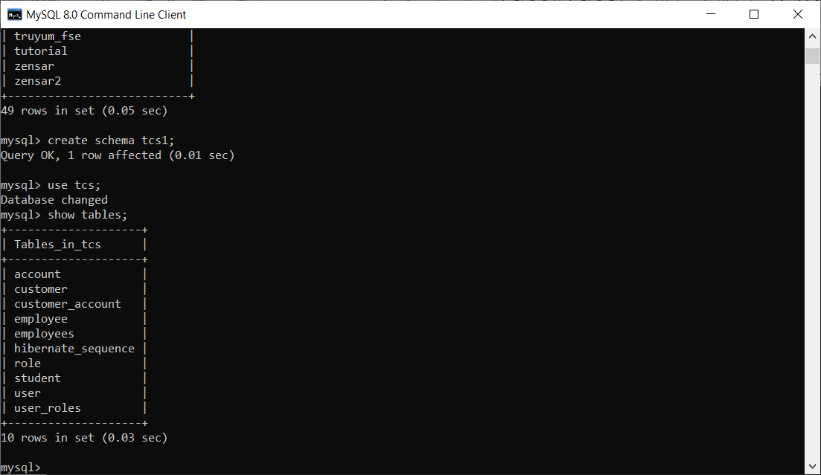

Select * from employee;

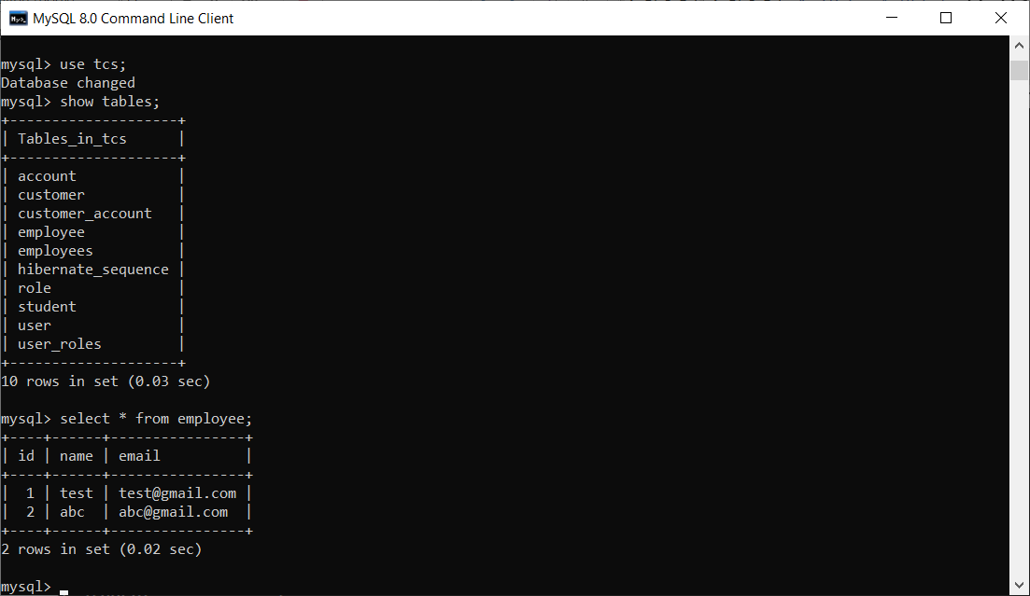

Open MySQL Workbench

Create a table.

CREATE TABLE `tcs1`.`employee` (

`id` INT NOT NULL AUTO_INCREMENT,

`name` VARCHAR(45) NULL,

`email` VARCHAR(125) NULL,

PRIMARY KEY (`id`));

INSERT INTO `tcs1`.`employee` (`name`, `email`) VALUES ('test', 'test@gmail.com');

INSERT INTO `tcs1`.`employee` (`name`, `email`) VALUES ('abc', 'abc@gmail.com');

Using JDBC API to interact with MySQL Database table(employee)

JPA – Java Persistence API

Serialization – Is the process of storing the state of an object in flat file (txt,rtf,.doc)

Persistence - Is the process of storing the state of an object in database table

In Java, everything is Object (Object is the root for everything)

In Database, everything is entity (Table, View, Function, Stored Procedure, Triggers, Sequence, Cursors)

JPA – is a Specification (Many interfaces & Abstract methods)

JPA is a Adv JAVA concepts. Persistence Jars needs to be added, then only we can use JPA codes.

JPQL = Java Persistence Query Language (Database independent way of interacting with database)

JPQL = JPQL query always use the Entity Bean class name, property names not the table name, column names.

Select * from employee = select e from employee e;

<https://www.gmail.com> (Protocol.type of resource//resourcelocation:port//resource_name)

JPA provides

Save(); -- Insert operation

Saveorupdate()

Persist() – Insert operation

getById()

NamedQueries

NamedNativeQueries

JPA Implementations

1. Hibernate – JPA Implementation – ORM Framework
2. iBatis
3. EclipseLink

Either the Table or Entity Bean class needs to be created.

Create a New JPA Project in Eclipse

1. File 🡪 New 🡪 Other 🡪 JPA Project

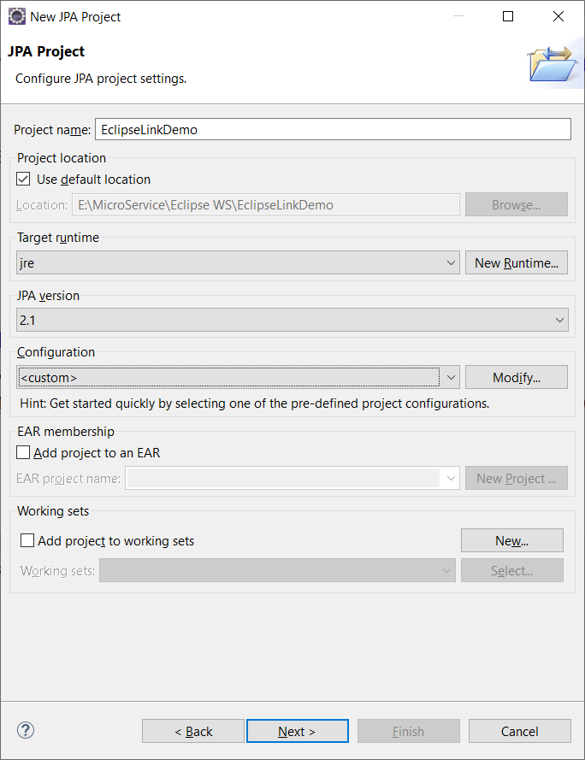

1. 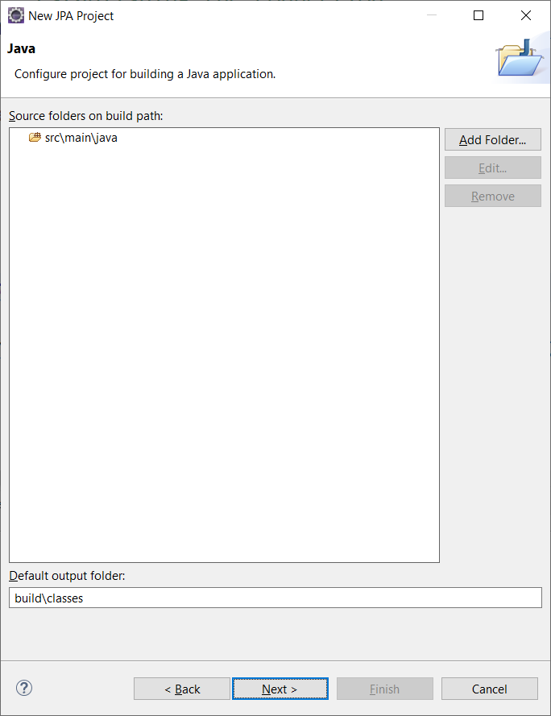

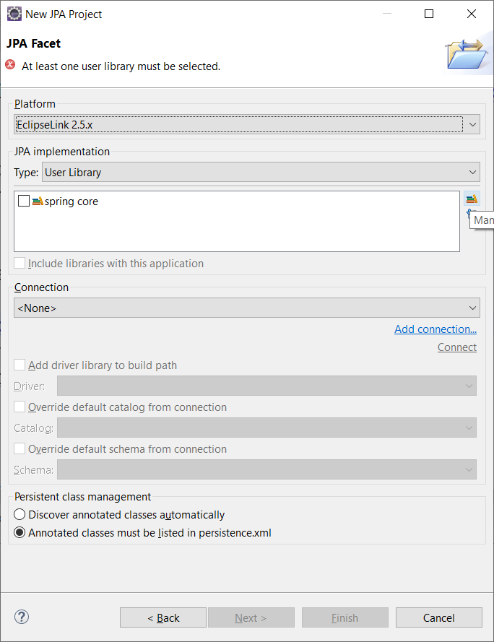

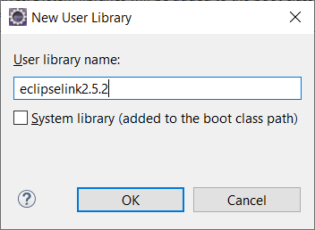

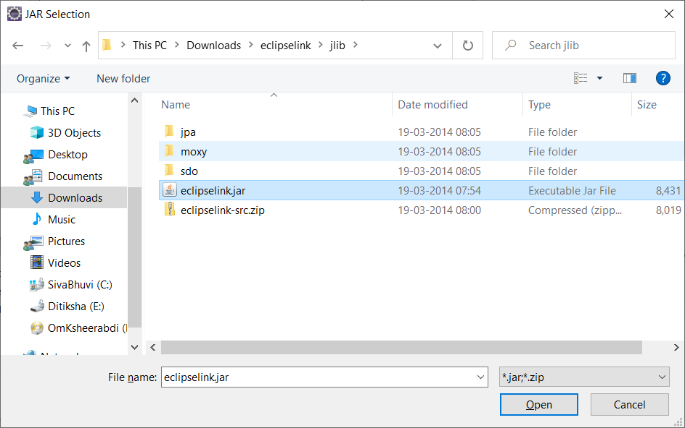

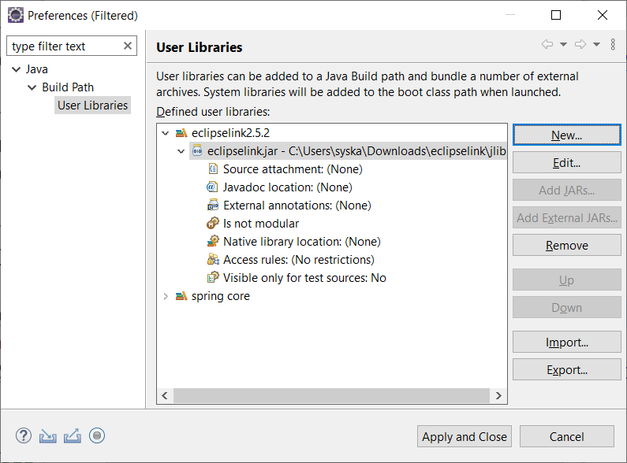

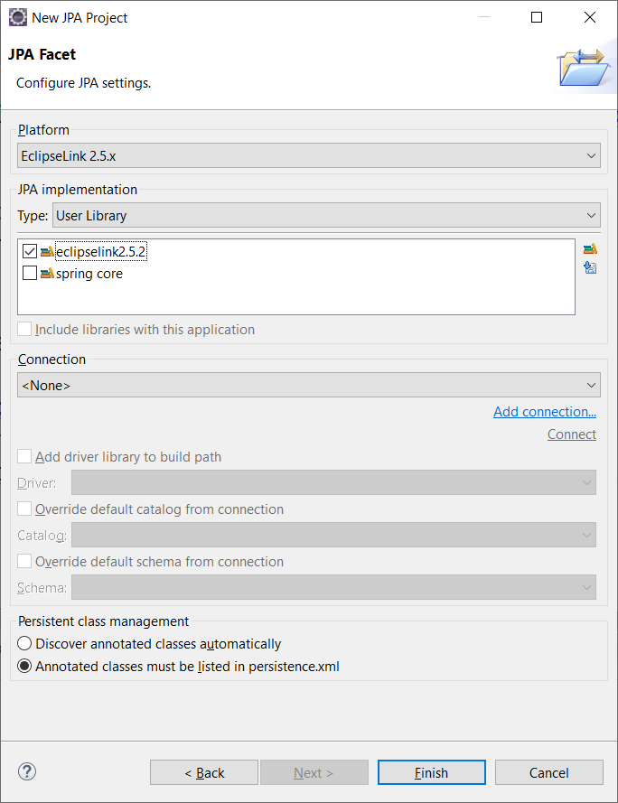

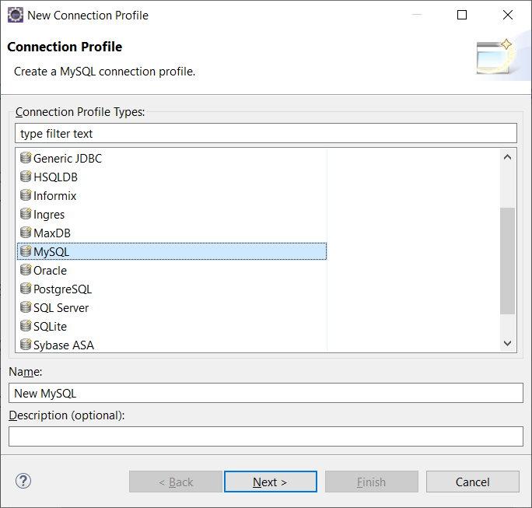

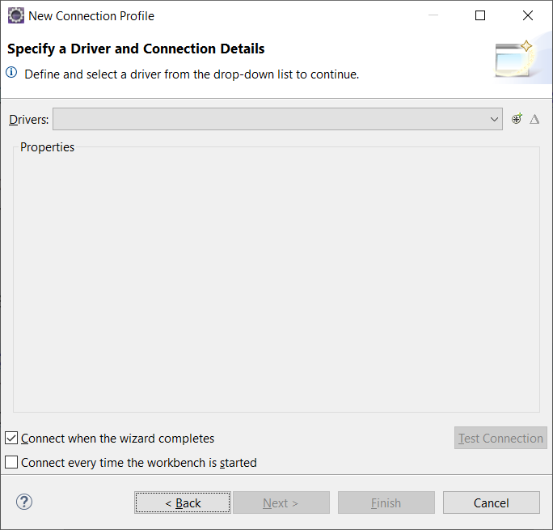

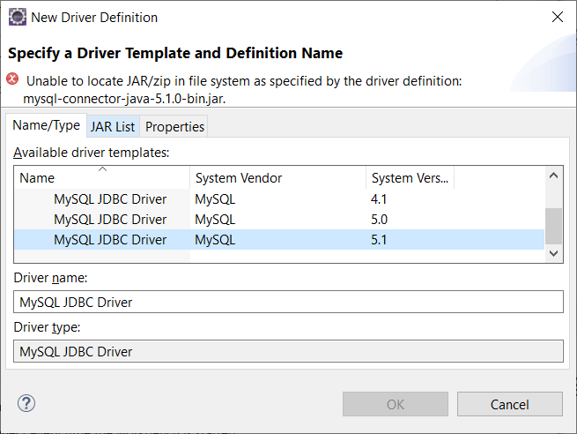

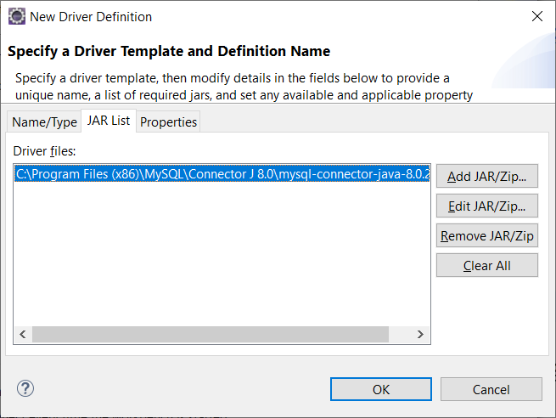

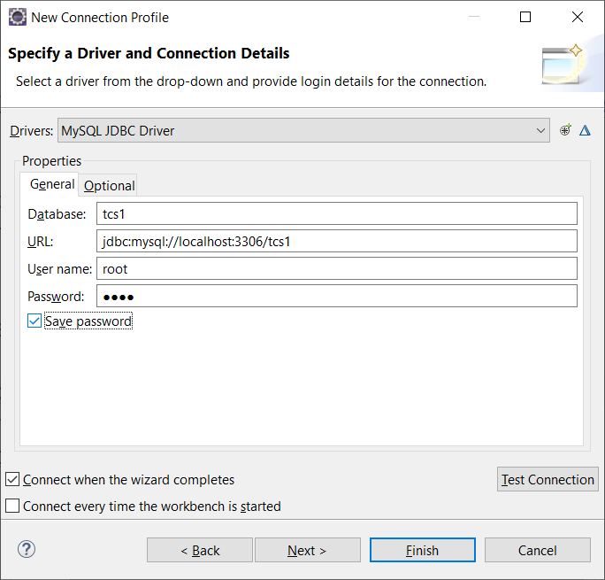

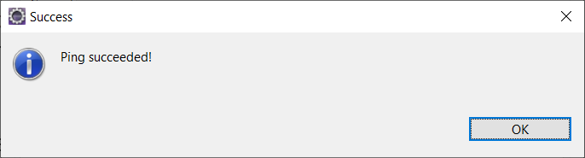

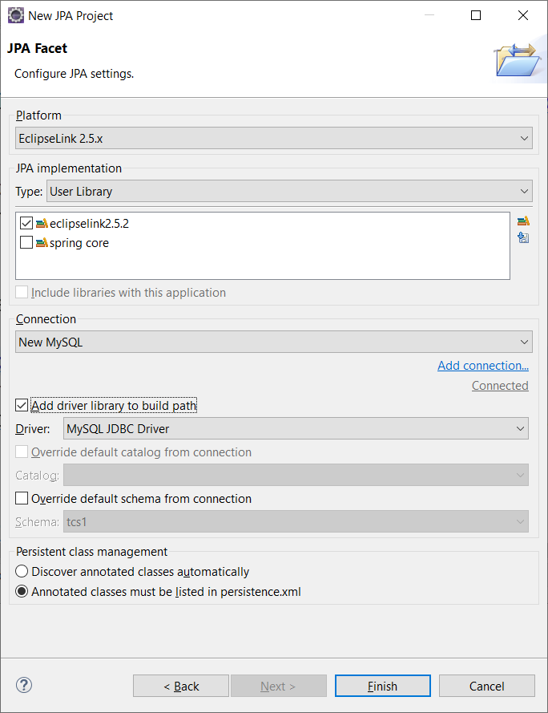

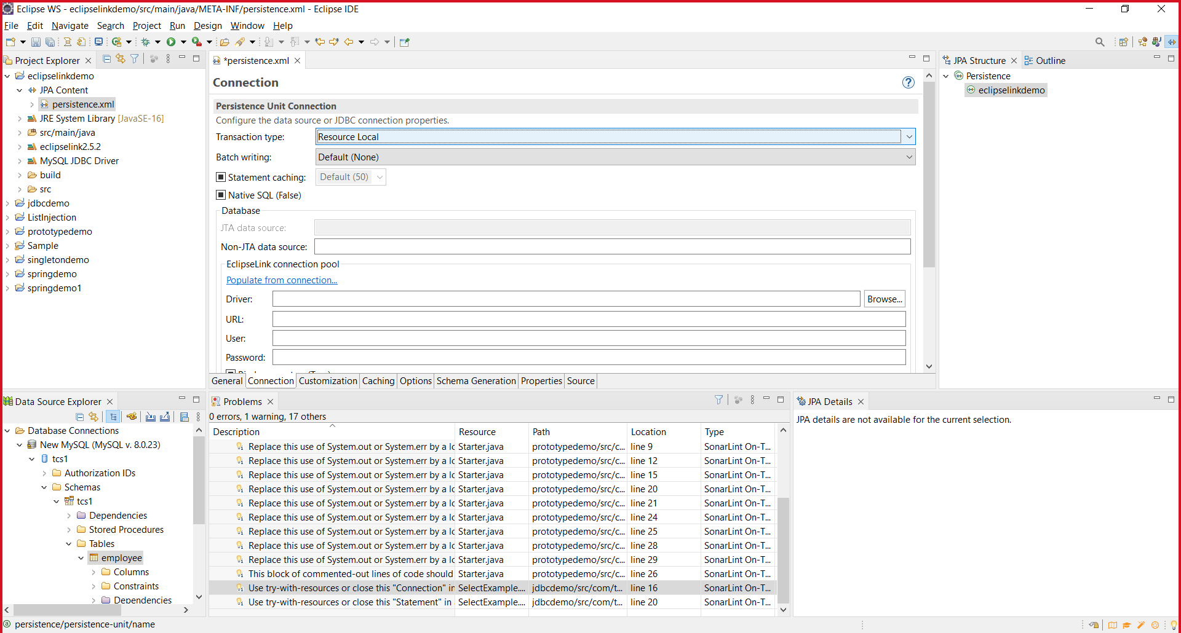

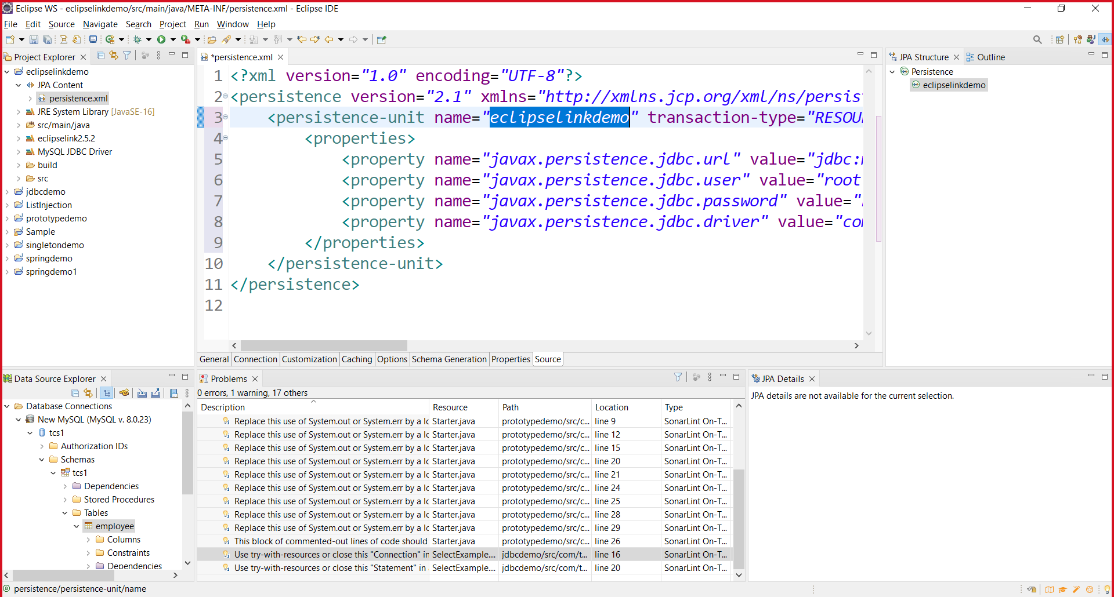

Create a New Table “Customer”

Id – integer

Username –

Password –

Name –

Email (Unique)

dateofBirth (Date)

Create a JPA project for Customer table. To perform the CRUD operations.

Hibernate is a ORM Framework

ORM – Object Relational Mapping

Object – JAVA Object

Relational – Relational Entity (Table)

Mapping – Connecting

ORM – Connecting Java with RDBMS Entities.

Hibernate is a Popular JPA Implementation.

<https://hibernate.org>

<https://sourceforge.net/projects/hibernate/files/hibernate-orm/5.6.5.Final/> -- Hibernate ORM download URL.

Hibernate is also a Open Source ORM Framework and it’s a JPA Implementation which is used to simplify the interaction of Java application with any RDBMS.

Adv of Hibernate

* Very Popular ORM Framework
* Provides Caching feature, Connection Pooling
* HQL – Hibernate Query Language (DB Independent Query)

<https://docs.jboss.org/hibernate/orm/5.6/userguide/html_single/Hibernate_User_Guide.html>

hibernate.cfg.xml = All Hibernate related configurations. (XML is both case and space sensitive)

employee.hbm.xml = Hibernate Mapping File (Many Mapping Files) – Optional / Also use annotations in Java Class directly.

Hbm = hibernate Mapping File (It connects Java Bean class to an Entity in Database)

Song.hbm.xml ==

hibernate.cfg.xml = hibernate configuration file (Only one hibernate.cfg.xml)

Inheritance Mapping

* TPH – Table Per Hierarchy (One Concrete Table for entire implementation == Not recommended approach)
* TPC – Table Per Concrete class - Recommended
* TPS – Table Per Sub Class

RDBMS – Relationship between Tables

1. One to One -- VoterID, PAN Card, Aadhaar, Passport
2. One to Many – Multiple House, Vehicles, Bank Accounts, Insurances
3. Many to Many – Each course can have many participants. Each participant can join many courses.

JPA

What is JPA – Java Persistence API

JPA Implementations – Hibernate, EclipseLink, iBatis

JPA is a Specification only

JPA simplifies the DB interaction process

JPA is a Adv Java concepts. All the Codes are defined inside javax.persistence package.

Configuration – XML/Annotation

EclipseLink – Examples (JPA Project in Eclipse) – Download and Add the Jars manually

Hibernate – ORM Framework, JPA Implementation

Hibernate 5.6.x jars – XML/Annotation Configuration

Hibernate Examples using Annotation & XML Mapping file.

Hibernate.cfg.xml – configuration file, <entity>.hbm.xml – Entity Mapping file.

Both xml file should be inside “src” folder only.

Relationships in DB Tables -